 

**CENTRAL INSTITUTE OF TOOL DESIGN, BALANAGAR, HYDERABAD**

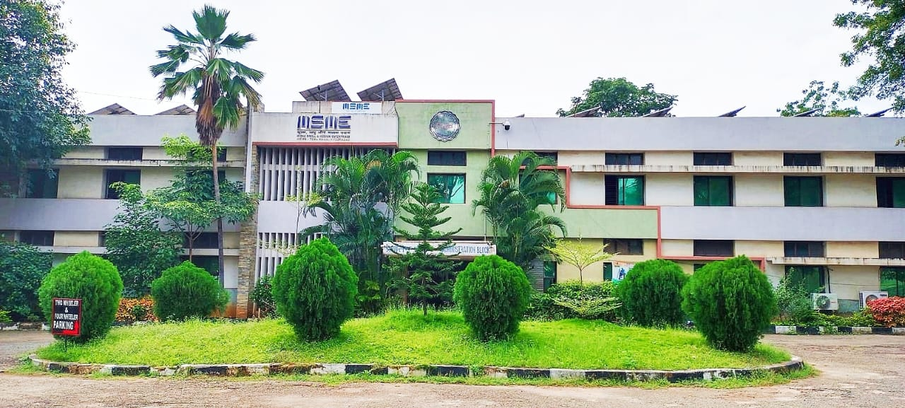

The Central Institute of Tool Design is a premier Institute in Asia to provide specialized training courses in Tool Engineering, CAD/CAM and Automation. The Institute was established in the year 1968 by the Government of India with the assistance of UNDP and ILO as an executing agency. The Institute conducts training programs right from Diploma to Post Graduation level. The institute is also conducting 2 M.E. programs (CAD/CAM & Tool Design) in collaboration with Osmania University and M-Tech (Mechatronics) in collaboration with JNTUH, Hyderabad. The Institute conducts International training programs in CAD/CAM, Tooling and Automation areas.

In addition to the training programs, the Institute also undertakes Design and manufacture of Tooling/Precision Components, Assemblies and Automation Systems. The Tool Room is equipped with sophisticated machines such as CNC 5-Axis & 4-Axis Vertical machining Centre from Bridgeport, USA, Harding CNC Lathe, CNC Charmilles Robo form EDM, CNC AGIE Wire cut EDM machine, Kellenberger CNC Cylindrical Grinding etc., supported by a Metrology Laboratory with CNC CMM with Reverse Engineering Facility and a calibration Centre to maintain Quality standards

**Acknowledgement**

Thank you Central Institute of tool design for giving us an opportunity to build a project subjected on Contactless Digital Tachometer. In order to build this project we have worked on our skills and tried to improve our potential in every possible step while working on the Project.

I am here over helmed in all humbleness and gratefulness to acknowledge our depth to all those who helped to put these ideas, well above to all those who have the level of simplicity and into something concrete.

I would like to express our special thanks of gratitude to our coordinator “**Mr. A. Sai Kumar”**, **“Ms. Bhaghyamma”**, as well as our Deputy Director **Shri. Sugyan Ranjan Dalai** who gave this golden opportunity to do this wonderful project on TACHOMETER, which also helped us in doing a lot of Research and we came to know about so many new things. We are really thankful to them.

Any attempt at any level can‘t be satisfactorily completed without the support and guidance of our Faculties and My Team members

I would like to thank our faculties who helped us a lot in gathering different information, collecting data and guiding us from time to time in making this project, despite of their busy schedules, they gave us different ideas in making this project unique.

I would like to take this opportunity to express my appreciation to all of my group members Snigdha Priya, Manjunadh and Raman for their encouragement, cooperation and contribution to the project…

We are also thankful to all the staff members for their encouragement and a deep appreciation to our family and friends, for all that they meant to us during the crucial times of our training period.

**CENTRAL INSTITUTE OF TOOL DESIGN, Hyderabad**

**DECLARATION**

We are the students of Central Institute of Tool Design, Hyderabad, Here to declare that project entitled “TACHOMETER” submitted in partial fulfillment of the requirements for the award of Diploma in Automation and Robotic Engineering. This dissertation is our original work and the project has not formed the basis for the award of any degree, associate ship, fellowship r any other similar titles and no part of it has been published or sent for the publication at the time of submission.

BY

B. Alekhya (19-20-29)

Y. Snigdha Priya (19-20-30)

K. Manjunadh (19-20-31)

B.H. Raman (19-20-32)

.

**CERTIFICATE**

**ABSTRACT**

A tachometer is a device that which measures the speed of a rotating objects like an electric motor or a crack shaft of a vehicle engine. Speed of an electric motor is determined by the number of revolutions made by the motor in one meter. In other words, speed is measured in 'RPM'. Here in this project, we designed a simple non-contact or contactless digital tachometer using 8051 microcontrollers, which can measure speed with an accuracy of 1 rev/sec. The basic principle behind the contactless digital tachometer involves a simple embedded system with a sensor, a controller and an actuator. The sensor used here is infrared transmitter receiver pair, the contactless used in the 8051-microcontroller loaded with a complied code and the actuator is display device, for displaying the speed of the motor.

Tachometer is a device that used for counting or for the measuring purpose of the number of revolutions (that is the total number rotations made by the device in unit of measuring time) of an object in unit time. It is expressed in the unit of RPS or RPM, the model uses a set of infrared transducer receiver to count the RPM pulses, and the Arduino microcontroller is used for the implementation of the project. The individual pulses are counted by the microcontroller to give the final output of the RPM.

For measuring the rotation celerity of a shaft or disc in a motor based device using a technique can be done by a microcontroller predicated tachometer. The technique what is used referred to a process which is embedded. To identify the rotation of the fan whose haste is being measured, here we have to use which is made of a components which plays the major roll named microcontroller, secondly an alphanumeric LCD display and an IR sensor. From the fan an infrared system will generate the pulse that means the number of rotation. After that it will be forwarded to a device which is microcontroller and the device will count the pulses very precisely. The readings of the counted pulses are now shown on the LCD display in RPM that is revolution per minute. This digital tachometer is benefitted us because of its cost efficiency. The quickness of a rotating object can be exhibit on the LCD screen. Behind the haste identification technology it accept utilize of IR sensor receiver and transmitter. In sundry solicitations it can also be utilized. The appropriateness of this device goes beyond the limit. At automotive sector, there are thousands of rotations in a minute can be occur which can easily identify by this device very appropriately.

**CHAPTER 1**

**8051 MICROCONTROLLER**

This project is based on Microcontroller using 8051

1.1 Microcontroller:

A microcontroller is a compact integrated circuit designed to govern a specific operation in an embedded system. A typical microcontroller includes a processor, memory and input/output (I/O) peripherals on a single chip. Sometimes referred to as an embedded controller or microcontroller unit (MCU), microcontrollers are found in vehicles, robots, office machines, medical devices, mobile radio transceivers, vending machines and home appliances, among other devices. They are essentially simple miniature personal computers (PCs) designed to control small features of a larger component, without a complex front-end operating system (OS).

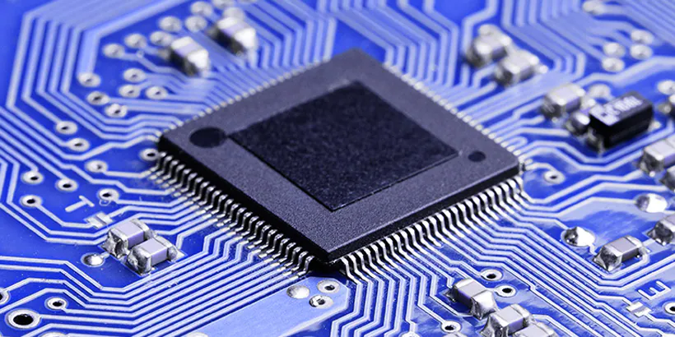

1.2 How do Microcontroller Works:

A microcontroller is embedded inside of a system to control a singular function in a device. It does this by interpreting data it receives from its I/O peripherals using its central processor. The temporary information that the microcontroller receives is stored in its data memory, where the processor accesses it and uses instructions stored in its program memory to decipher and apply the incoming data. It then uses its I/O peripherals to communicate and enact the appropriate action. Microcontrollers are used in a wide array of systems and devices. Devices often utilize multiple microcontrollers that work together within the device to handle their respective tasks.

For example, a car might have many microcontrollers that control various individual systems within, such as the anti-lock braking system, traction control, fuel injection or suspension control. All the microcontrollers communicate with each other to inform the correct actions. Some might communicate with a

more complex central computer within the car, and others might only communicate with other microcontrollers. They send and receive data using their I/O peripherals and process that data to perform their designated tasks.

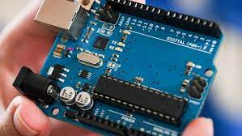

1.3 Elements of Microcontroller:

The core elements of a microcontroller are:

1.3.1 The Processor (CPU):

A processor can be thought of as the brain of the device. It processes and responds to various instructions that direct the microcontroller's function. This involves performing basic arithmetic, logic and I/O operations. It also performs data transfer operations, which communicate commands to other components in the larger embedded system.

1.3.2 Memory:

A microcontroller's memory is used to store the data that the processor receives and uses to respond to instructions that it's been programmed to carry out.

A microcontroller has two main memory types:

* Program memory: Which stores long-term information about the instructions that the CPU carries out. Program memory is non-volatile memory, meaning it holds information over time without needing a power source.
* Data memory: Which is required for temporary data storage while the instructions are being executed. Data memory is volatile, meaning the data it holds is temporary and is only maintained if the device is connected to a power source.

1.3.3 I/O peripherals:

The input and output devices are the interface for the processor to the outside world. The input ports receive information and send it to the processor in the form of binary data. The processor receives that data and sends the necessary instructions to output devices that execute tasks external to the microcontroller. While the processor, memory and I/O peripherals are the defining elements of the microprocessor, there are other elements that are frequently included. The term I/O peripherals itself simply refers to supporting components that interface with the memory and processor. There are many supporting components that can be classified as peripherals. Having some manifestation of an I/O peripheral is elemental to a microprocessor, because they are the mechanism through which the processor is applied.

1.3.4 Bus:

Bus is a group of wires which uses as a communication canal or acts as means of data transfer. The different bus configuration includes 8, 16 or more cables. Therefore, a bus can bear 8 bits, 16 bits all together.

* Types of Buses in Microcontroller:
* Address Bus: 8051 microcontrollers is consisting of 16 bit address bus. It is generally be used for transferring the data from Central Processing Unit to Memory.
* Data bus: 8051 microcontroller is consisting of 8 bits data bus. It is generally be used for transferring the data from one peripherals position to other peripherals.

1.3.5 Oscillator:

As the microcontroller is digital circuit therefore it needs timer for their operation. To perform timer operation inside microcontroller it required externally connected or on-chip oscillator. Microcontroller is used inside an embedded system for managing the function of devices. Therefore, 8051 uses the two 16 bit counters and timers. For the operation of this timers and counters the oscillator is used inside microcontroller.

1.3.6 Other supporting elements of a microcontroller include:

* Analog to Digital Converter (ADC): An ADC is a circuit that converts analog signals to digital signals. It allows the processor at the center of the microcontroller to interface with external analog devices, such as sensors.
* Digital to Analog Converter (DAC): A DAC performs the inverse function of an ADC and allows the processor at the center of the microcontroller to communicate its outgoing signals to external analog components
* System bus: The system bus is the connective wire that links all components of the microcontroller together.
* Serial port: The serial port is one example of an I/O port that allows the microcontroller to connect to external components. It has a similar function to a USB or a parallel port but differs in the way it exchanges bits.

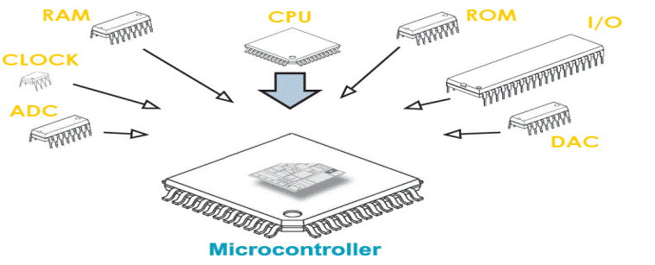

1.4 Microcontroller Features:

A microcontroller's processor will vary by application. Options range from the simple 4-bit, 8-bit or 16-bit processors to more complex 32-bit or 64-bit processors. Microcontrollers can use volatile memory types such as Random Access Memory (RAM) and Non-Volatile memory types. This includes flash memory, Erasable Programmable Read-Only Memory (EPROM) and Electrically Erasable Programmable Read-Only Memory (EEPROM).

Generally, microcontrollers are designed to be readily usable without additional computing components because they are designed with sufficient onboard memory as well as offering pins for general I/O operations, so they can directly interface with sensors and other components.

Microcontroller architecture can be based on the Harvard architecture or von Neumann architecture, both offering different methods of exchanging data between the processor and memory. With a Harvard architecture, the data bus and instruction are separate, allowing for simultaneous transfers. With a Von Neumann architecture, one bus is used for both data and instructions.

Microcontroller processors can be based on Complex Instruction Set Computing (CISC) or Reduced Instruction Set Computing (RISC). CISC generally has around 80 instructions while RISC has about 30, as well as more addressing modes, 12-24 compared to RISC's 3-5. While CISC can be easier to implement and has more efficient memory use, it can have performance degradation due to the higher number of clock cycles needed to execute instructions. RISC, which places more emphasis on software, often provides better performance than CISC processors, which put more emphasis on hardware, due to its simplified instruction set and, therefore, increased design simplicity, but because of the emphasis it places on software, the software can be more complex. Which ISC is used varies depending on application.

When they first became available, microcontrollers solely used assembly language. Today, the C programming language is a popular option. Other common microprocessor languages include Python and JavaScript.

MCUs feature input and output pins to implement peripheral functions. Such functions include analog-to-digital converters, liquid crystal display (LCD) controllers, real-time clock (RTC), universal synchronous/asynchronous receiver transmitter (USART), timers, universal asynchronous receiver transmitter (UART) and universal serial bus (USB) connectivity. Sensors gathering data related to humidity and temperature, among others, are also often attached to microcontrollers.

1.5 Types of Microcontroller:

Common MCUs include the Intel MCS-51, often referred to as an 8051 microcontroller, which was first developed in 1985; the AVR microcontroller developed by Atmel in 1996; the programmable interface controller (PIC) from Microchip Technology; and various licensed Advanced RISC Machines (ARM) microcontrollers. A number of companies manufacture and sell microcontrollers, including NXP Semiconductors, Renesas Electronics, Silicon Labs and Texas Instruments.

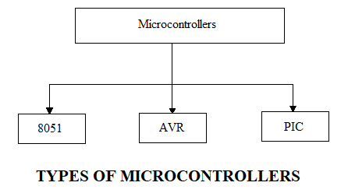

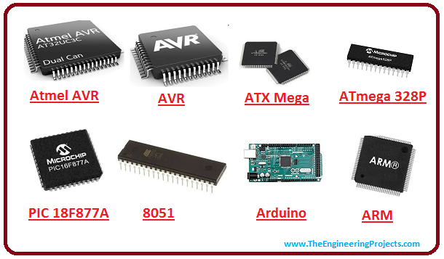

* PIC Microcontroller:

PIC Stands for Peripheral Interface Controller is a kind of microcontroller components was used in the development of electronics, computer robotics, and similar devices. Even though the PIC was produced by Microchip technology and based on hardware computing architecture, here the code and data are placed in separate registers to increase the input and output. Pic has a built-in data memory, data bus and dedicated microprocessor for preparing all I/O purposes and methods

* ARM Microcontroller:

ARM stands for Advanced RISC Machine. It’s the most popular Microcontrollers Programming in the digital embedded system world, and most of the industries prefer only ARM microcontrollers since it consists of significant features to implement products with an excellent appearance. It is cost sensitive and high-performance device which has been used in a wide range of application such as Industrial Instrument control systems, wireless networking and sensors, and automotive body systems, etc.

* 8051 Microcontroller:

Intel created 8051 microcontrollers in 1981. It is an 8bit microcontroller. It’s made with 40 pins DIP (Dual inline package), 4kb if ROM storage and 128 bytes of RAM storage, 2 16 bit timer. It consists of are four parallel 8 bit ports, which are programmable as well as addressable as per the specification.

* AVR Microcontroller :

AVR stands for Alf and Vegard's RISC Processor. It was the modified Harvard architecture machine, where program and data were stored in the separate physical memory system that appears in different address spaces, but having the ability to browse information things from program memory victimization particular directions. AVR isn't associate degree signifier and doesn't symbolize something specially.

* MSP Microcontroller:

MSP stands for Mixed Signal Processor. It’s the family from Texas Instruments. Built around a 16 -bit CPU, the MSP is designed for low cost and respectively, low power dissipation embedded statements. It’s the controller's appearance is directly related to the 16-bit data bus, and seven addressing modes and the decreased instructions set, which allows a shorter, denser programming code for fast performance. The Range of Microcontroller is an IC chip that executes programs for controlling other device or machines. It is a micro-device which is used for control of other device machines that’s why it’s called Microcontrollers Programming.

Microcontroller Applications:

Microcontrollers are used in multiple industries and applications, including in the home and enterprise, building automation, manufacturing, robotics, automotive, lighting, smart energy, industrial automation, communications and Internet of Things (IOT) deployments. One very specific application of a microcontroller is its use as a digital signal processor. Frequently, incoming analog signals come with a certain level of noise. Noise in this context means ambiguous values that cannot be readily translated into standard digital values. A microcontroller can use its ADC and DAC to convert the incoming noisy analog signal into an even outgoing digital signal. The simplest microcontrollers facilitate the operation of electromechanical systems found in everyday convenience items, such as ovens, refrigerators, toasters, mobile devices, key fobs, video game systems, televisions and lawn-watering systems. They are also common in office machines such as photocopiers, scanners, fax machines and printers, as well as Smart meters, ATMs and security systems. More sophisticated microcontrollers perform critical functions in aircraft, spacecraft, ocean-going vessels, vehicles, medical and life-support systems as well as in robots. In medical scenarios, microcontrollers can regulate the operations of an artificial heart, kidney or other organs. They can also be instrumental in the functioning of prosthetic devices.

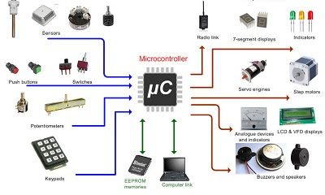 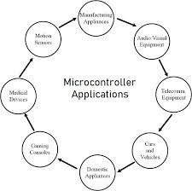

Microcontrollers vs. microprocessors:

The distinction between microcontrollers and microprocessors has gotten less clear as chip density and complexity has become relatively cheap to manufacture and microcontrollers have thus integrated more "general computer" types of functionality. On the whole, though, microcontrollers can be said to function usefully on their own, with a direct connection to sensors and actuators, where microprocessors are designed to maximize compute power on the chip, with internal bus connections (rather than direct I/O) to supporting hardware such as RAM and serial ports. Simply put, coffee makers use microcontrollers; desktop computers use microprocessors. Microcontrollers are less expensive and use less power than microprocessors. Microprocessors do not have built-in RAM, read-only memory (ROM) or other peripherals on the chip, but rather attach to these with their pins. A microprocessor can be considered the heart of a computer system, whereas a microcontroller can be considered the heart of an embedded system

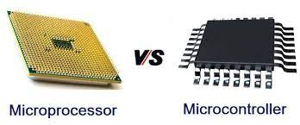

8051 Microcontroller Architecture

8051 microcontroller is designed by Intel in 1981. It is an 8-bit microcontroller. It is built with 40 pins DIP (dual inline package), 4kb of ROM storage and 128 bytes of RAM storage, 2 16-bit timers. It consists of are four parallel 8-bit ports, which are programmable as well as addressable as per the requirement. An on-chip crystal oscillator is integrated in the microcontroller having crystal frequency of 12MHz. Let us now discuss the architecture of 8051 Microcontroller. In the following diagram, the system bus connects all the support devices to the CPU. The system bus consists of an 8-bit data bus, a 16-bit address bus and bus control signals. All other devices like program memory, ports, data memory, serial interface, interrupt control, timers, and the CPU are all interfaced together through the system bus

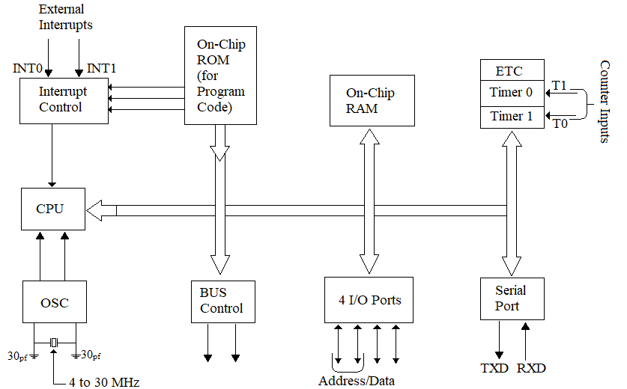

The pin diagram of 8051 microcontroller looks as follows:

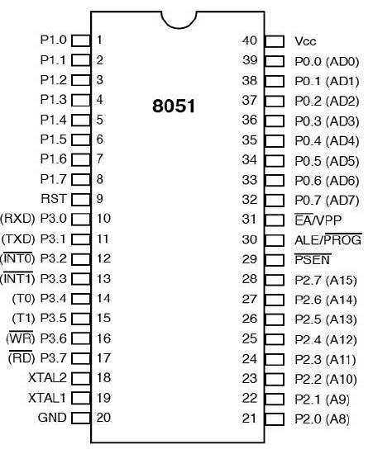

* Pins 1 to 8: These pins are known as Port 1. This port doesn’t serve any other functions. It is internally pulled up, bi-directional I/O port.
* Pin 9: It is a RESET pin, which is used to reset the microcontroller to its initial values.
* Pins 10 to 17: These pins are known as Port 3. This port serves some functions like interrupts, timer input, control signals, serial communication signals RxD and TxD, etc.
* Pins 18 & 19: These pins are used for interfacing an external crystal to get the system clock.
* Pin 20: This pin provides the power supply to the circuit.
* Pins 21 to 28: These pins are known as Port 2. It serves as I/O port. Higher order address bus signals are also multiplexed using this port.
* Pin 29: This is PSEN pin which stands for Program Store Enable. It is used to read a signal from the external program memory.
* Pin 30: This is EA pin which stands for External Access input. It is used to enable/disable the external memory interfacing.
* Pin 3: This is ALE pin which stands for Address Latch Enable. It is used to demultiplex the address-data signal of port.
* Pins 32 to 39: These pins are known as Port 0. It serves as I/O port. Lower order address and data bus signals are multiplexed using this port.
* Pin 40: This pin is used to provide power supply to the circuit.

8051 microcontrollers have 4 I/O ports each of 8-bit, which can be configured as input or output. Hence, total 32 input/output pins allow the microcontroller to be connected with the peripheral devices.

Pin configuration, i.e. the pin can be configured as 1 for input and 0 for output as per the logic state.

Input /Output (I/O) pin: All the circuits within the microcontroller must be connected to one of its pins except P0 port because it does not have pull-up resistors built-in.

Input pin: Logic 1 is applied to a bit of the P register. The output FE transistor is turned off and the other pin remains connected to the power supply voltage over a pull-up resistor of high resistance.

Port 0: The P0 (zero) port is characterized by two functions

When the external memory is used then the lower address byte (addresses A0A7) is applied on it, else all bits of this port are configured as input/output.

When P0 port is configured as an output then other ports consisting of pins with built-in pull-up resistor connected by its end to 5V power supply, the pins of this port have this resistor left out.

Input Configuration:

If any pin of this port is configured as an input, then it acts as if it “floats”, i.e. the input has unlimited input resistance and in-determined potential.

Output Configuration:

When the pin is configured as an output, then it acts as an “open drain”. By applying logic 0 to a port bit, the appropriate pin will be connected to ground (0V), and applying logic 1, the external output will keep on “floating”.

In order to apply logic 1 (5V) on this output pin, it is necessary to build an external pullup resistor.

Port 1:

P1 is a true I/O port as it doesn’t have any alternative functions as in P0, but this port can be configured as general I/O only. It has a built-in pull-up resistor and is completely compatible with TTL circuits.

Port 2:

P2 is similar to P0 when the external memory is used. Pins of this port occupy addresses intended for the external memory chip. This port can be used for higher address byte with addresses A8-A15. When no memory is added then this port can be used as a general input/output port similar to Port 1.

Port 3:

In this port, functions are similar to other ports except that the logic 1 must be applied to appropriate bit of the P3 register.

Pins Current Limitations:

When pins are configured as an output (i.e. logic 0), then the single port pins can receive a current of 10mA.

When these pins are configured as inputs (i.e. logic 1), then built-in pull-up resistors provide very weak current, but can activate up to 4 TTL inputs of LS series.

If all 8 bits of a port are active, then the total current must be limited to 15mA (port P0: 26mA).

If all ports (32 bits) are active, then the total maximum current must be limited to 71mA.

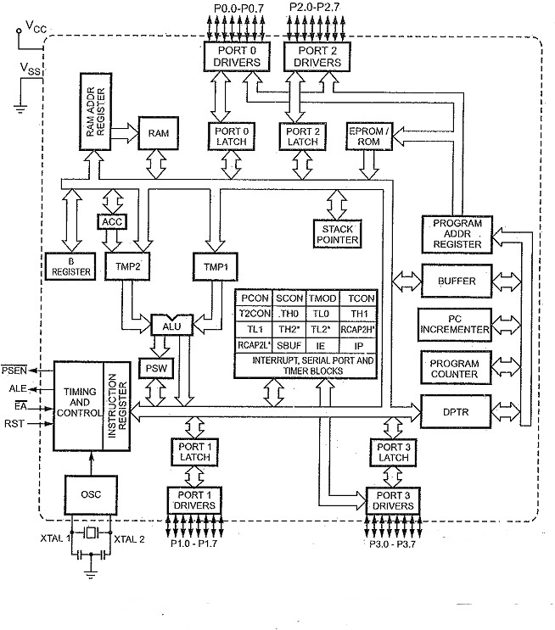

FEATURES OF MICRO CONTROLLERS:

* All the peripherals are integrated into a signal chip. Therefore the overall system cost is low.
* The product is of a small size as compared to microprocessor based system and is thus very handy.
* The system design requires very little efforts and is easy to trouble shoot and maintain.
* As the peripherals are integrated with a microprocessor, the system is more reliable.
* The micro controller with on-chip ROM provides a software security features which is not available with microprocessor based system.
* Though micro controller have on chip RAM,ROM and I/O ports, additional RAM,ROM, I/O ports may be interfaced externally. If required. It having four register banks
* It having four register banks
* 64K bytes on-chip programmable memory (ROM)
* 128 bytes on-chip data memory (RAM)
* Address bus is 16-bit unidirectional
* Data bus is 8-bit bidirectional
* 128 user defined flags
* 16 bit timers
* 32 general purpose registers each of 8-bit
* 8051 microcontroller offers a number of special features such as ADC, UARTs, Op-amp, etc.

APPLICATIONS:

* Even with the development of many advanced and superior Microcontrollers, 8051 Microcontroller is still being used in many embedded system and applications.
* Some of the applications of 8051 Microcontroller are mentioned below:
* Communication Systems (Mobile Phones, Intercoms, Answering Machines, Paging Devices, etc.)
* Consumer Appliances (TV Tuners, Remote controls, Computers, Sewing Machines, etc.)
* Home Applications (TVs, VCR, Video Games, Camcorder, Music Instruments, Home Security Systems, Garage Door Openers, etc.)
* Office (Fax Machines, Printers, Copiers, Laser Printers, etc.).
* Automobiles (Air Bags, ABS, Engine Control, Transmission Control, Temperature Control, Keyless Entry, etc)
* Aeronautical and Space
* Medical Equipment
* Defense Systems
* Robotics
* Industrial Process and Flow Control
* Radio and Networking Equipment
* Remote Sensing

**CHAPTER 2**

**INTRODUCTION**

2.1 Introduction:

At numerous aspects of commercial and industrial performance, it is routinely compulsory to determine the cyclic speed of different appliances. Such type of determination may be completed in many ways. Generally it is recline on the behavior of the object’s mechanism. Tachometer is one of those methods by which anyone can easily measure the number of rotation. A device which can measure the cyclic speed of a shaft or else disc is known as a tachometer. The word tachometer is obtained from two Greek words tacos (“speed") & matron ("measure"). When it operates it follows similar principle of a tachometer beget and it is too verbalize, when without connecting a motor to a resistance or load the time of operating the motor. By a tachometer generator measuring the voltage which is engendered, whatever it is mechanically affixed to it anyone can facilely determine the cyclic speed. A tachometer’s operation can be electromagnetic, electrical or optical predicated. Thus revolution-counter is another identity of a tachometer and surprisingly the unit is also as same which is revolution per minute in short RPM.

The basic operating principle of a mechanical tachometer is a movable magnet driven by the rotating input shaft that interacts closely with an eddy current sensor that generates the reading. The rotating magnet within the sensor forces the indicator needle to show the proportional reading on the given output method as per the engine speed, whereas a countering spring acts against the sensors force to bring it to a stable stopping point (output reading on the dial). As compared to a digital tachometer, the traditional kind faces many issues like the probability of mechanical failure, wear of parts with age that might give errors.

* The basic characteristics of an 8051 microcontroller are as mentioned, Flash Memory=8kB, RAM=256 Bytes, Clock speed=12Mhz, one operating cycle=12 clock cycles, 8051 operating voltage is generally between 5 V to 6.6 V and minimum current required is 25 m Amps.
* Single instruction executed in 2 machine cycles General IDE and burner can used to write and compile code in assembly language for 8051. Programmer needs to know about the registers and pins and their specific operations by compiler along with the use of specific SFR,s and interrupt routines to write code for 8051 microcontroller. To code a 8051 controller we need a burner also known as an external programmer as it does not directly interact directly with a modern computer.
* It is tough to program in Assembly language.
* No EEPROM.
* Arduino boards need a minimum of 5 V to operate and work up to a rage of 20V. It can b directly powered by the device being used to code it testing as it is connected using a basic USB cable that is easily available. They can also be powered using independent sources using an external adapter.
* ISSN: 2088-8708 Int J Electronic & Comp Engineering, Vol. 11, No. 1, February 2021 : 293 - 299294
* Arduino is present in logic 5 V and 3.3 V. That lets us use Arduino more adaptably as compared to an 8051 and can interfaced with a 5 V logic input device and lower voltage sensors with minimum requirements that can be taken directly from the arduino board. That eliminates the need of a level Converter.
* Minimum required powering current is 25mAmps that is like 8051.
* Its GPIO pins be used alongside 40mamps of current which is very advantageous when compared to an 8051’s on board gpio.
* Arduino uno Flash Memory is fixed at 32kB, Arduino uno’s RAM is pre-set to 2kB, Arduino uno EEPROM at 1kB, clock speed at 16Mhz that can be increase upto 20Mhz, here we consider it as: one operating cycle = 1 operating clocks cycle.
* An instruction run for a single operation cycle.
* It is easier to code in c programming language.
* PIC needs more than a single clock cycle for every instruction. AVRC programming lets us execute most of the instructions in a single clock cycle.
* PIC has a fixed memory stack that has very limited space, so it limits us from stacking them very deeply and hence subroutines are limited to a certain extent and C compiler cannot make big stack frames. Stack pointers are used to address all registers of RAM that are available in the given memory space.
* PIC microcontroller can be used to directly address 256 bytes of memory that has to be used by changing the bank after every instruction cycle using extra instructions to change. AVR has an advantage over it as it can directly access 64k of the memory.
* Cripple ware is one of the few free pic compilers. AVR free compiler being developed and updated by a larger team.
* PIC has a ‘W’ register whereas AVR has 32 registers that can be used for general purpose as well and includes multiple pairs which can be used as pointers.

The first mechanical tachometer was similar in operation to a centrifugal governor. The inventor of the first mechanical tachometer is assumed to be a German engineer Dietrich Uhlhorn; he used it for measuring the speed of machines in 1817. Since after then, it has been used to measure the speed of locomotives in automobiles, trucks, tractors and aircrafts. Early tachometer designs were based on the principle of mono stable multi vibrator, which has one stable state and one quasi stable state. The circuit remained in a stable state, producing no output. However, When it receives triggering current pulse from the ignition system, the circuit transitions to the quasi stable state for a given time before returning again to the stable state. This way, each ignition pulse produced a clean pulse of fixed duration that was fed to the gauge mechanism. The more of such fixed duration pulses the gauge received per second, the higher it read.

The mono stable multi vibrator is still used in tachometers today, although the tendency is to use voltage pulses rather than current pulses, the latter requiring that the ignition coil current passes through the tachometer on its way to the coils. Later designs of tachometer were in no way to do any improvement on the early type; indeed the change seemed to have been made to be more economical. Integrated Circuit (IC) where in their infancy in the late 1960's and was both expensive and not proven to be robust in automobile applications.

2.2 Problem Statement:

To design a tachometer device that measures the speed (rpm) of a DC motor. Sensor module: This module will contain sensors that will detect the speed of the motor. Display module: This module will receive data from the sensors and calculate the speed. The speed will be displayed on any displaying unit like LCD.

2.3 Objective:

The main objective of solar base ups system to get more power and how we serve power to our rural are to save energy in this projects we show how to get energy from sun and how to calculate data to our load and battery. The main object is save power and generated voltage and current .we use ac to dc converter to get dc power to ac power .so we describe our thesis book to how to convert dc to ac power.

2.4 Objective of the project:

Generally, directly emitting the infra-red beam the object sensor using infrared reflection is being performed its work and when the white object surface is encountered by the beam then it will be returned to the phototransistor via reflection. After that the 2N3904 transistor and the phototransistor will begin to lead and across the 470 Ohm resistor it will generate enough voltage to be deliberated by the microcontroller named ATMEGA8a. It is built in a module named Capture Compare Pulse width modulation in short CCP module, as the logical “1” at the input port. When the ebony tire surface is encountered by the infra-red beam, at that time transistor 2N3904 and both of the phototransistor will immediately turn off. Across the resistor 470 Ohm the voltage will drop down to 3.5 volt at logical “0”.

2.5 Scopes:

The main assignment of a tachometer is to measure the number of rotation. It is known as contact-type tachometer when it is in direct contact with the shaft which is being rotating. The above mentioned tachometer is being attached to the electric motor or else other rotating machineries. A magnetic sensor or optical encoder can additionally be connected to the tachometer. Which will helps to count the RPM of any Machinery.

2.6 Methodology:

A digital tachometer could be designed through a several ways, as the main control unit of the scheme here we choose this method. A microcontroller is used for this section. As the detection mechanism of the rotation of any shaft the infrared transmission mechanism is being applied here. For exhibition of any result an alphanumeric LCD screen is being used and for detection of the rotation of the shaft a proximity sensor is used. In this circumstance from the proximity sensor the counted pulses will originate, at that time if any element which is reflected is going in front of it immediately detected. In this way for each and every rotation of the shaft of any machine it will send an output pulse. The microcontroller will be accepted those pulses and start to counted. At the end of the process he result of the rotation will displayed in the alphanumeric LCD screen.

2.7 Organization of the Report:

This project report has six chapters in total. The first chapter describes an idea about our project construction and design of wireless tachometer system, Brief description of the project, problem statement, scopes and methodology. The second chapter about history, block diagram, circuit diagram, list of components. The Chapter third about component description, cost analysis of our system. The Chapter fourth about software analysis & program explanation. The chapter five hardware implementation. Then chapter six describes result & discussion properly. Finally, chapter seven gives the concluding remarks, limitation of our system and suggestion for the future works.

**CHAPTER 3**

**SYSTEM REVIEWS**

**3.1 Classification of Digital Tachometers:**

Digital Tachometers are classified into four types based on the data acquisition and measurement techniques. Based on the data acquisition technique, the tachometers are of the following types:

* Contact Type
* Non-Contact Type

3.1.1 Contact Type Tachometers:

A Tachometer which is in contact with the rotating shaft is known as Contact Type Tachometer. This kind of tachometer is generally fixed to the machine or electric motor. An optical encoder or magnetic sensor can also be attached to this so that it measures its RPM.

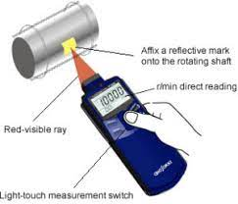

3.1.2 Non-Contact Type Tachometer:

A tachometer that does not need any physical contact with the rotating shaft is called as noncontact digital tachometer. In this type, a laser or an optical disk is attached to the rotating shaft, and it can be read by an IR beam or laser, which is directed by the tachometer. These types of tachometers are efficient, durable, accurate, compact, and visible from long distance.

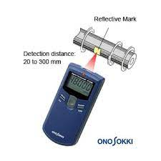

Based on the measurement technique, the tachometers are of the following types:

* Time Measurement Digital Tachometer
* Frequency Measurement Digital Tachometer

3.1.3Time Measurement Digital Tachometer:

A tachometer that calculates the speed by measuring the time interval between incoming pulses is known as a time-based digital tachometer. The resolution of this tachometer is independent of the speed of the measurement, and it is more accurate for measuring low speed.

3.1.4 Frequency Measurement Digital Tachometer:

A tachometer that calculates the speed by measuring the frequency of the pulses is called a frequency-based digital tachometer. This type of tachometer is designed by using a red LED, and the revolution of this tachometer depends on the rotating shaft, and it is more accurate for measuring high speed. These tachometers are of low-cost and high-efficiency, which is in between 1Hz-12KHz.

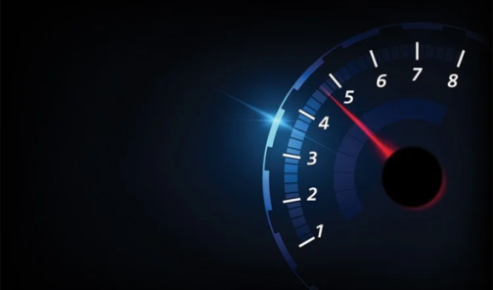

3.1.5 Design Methodology:

Though there are several ways by which a digital tachometer could be designed, we choose this method which makes use of a microcontroller as the main control unit of the device, infrared transmission technique as the detection mechanism, an alphanumeric LCD module for display and a proximity sensor for detection of the rotation of the shaft whose speed is being measured. In these case of these the counted pulses will come from the proximity sensor, which will detect any reflective element passing in front of it, and thus will give an output pulse for each and every rotation of the shaft. Those pulses will be fed to the microcontroller and counted. The result will then be displayed on the LCD module.

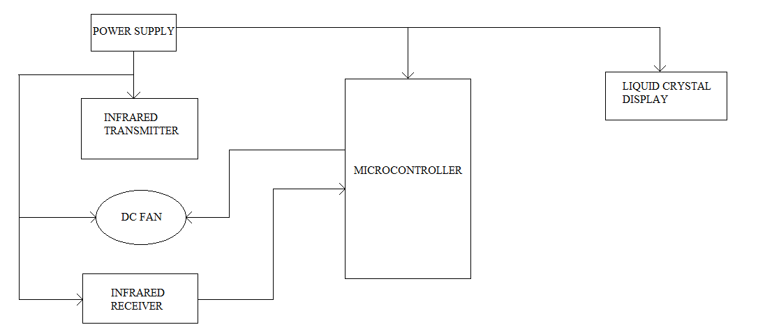

3.2 GENERAL BLOCK DIAGRAM:

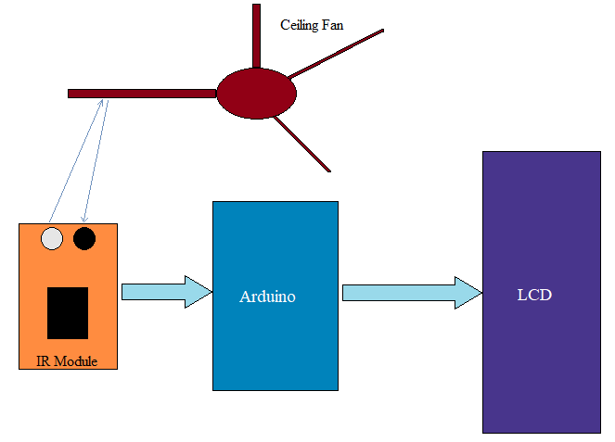

3.2.1. Description of Block Diagram:

From the above tachometer circuit we can see that, it comprises ATMEGA8a Pro Mini, a buzzer, a LCD screen and IR sensor module. ATMEGA8a controls the whole procedure. The procedure is almost as like as generating pulse by IR sensor module. This is consequent to Remonstrate detection, performing calculation of RPM of the shaft and at last sending the result that is RPM value to the alphanumeric LCD screen. For sensing the object IR sensor is used. By an inbuilt potentiometer situated on IR module, the sensitivity of this module can easily be set. IR sensor module comprises with detector infrared rays called photo diode and an IR transmitter. Infrared rays are transmitted by IR transmitter, when this rays decline on any surface, they reflect back to the receiver and experienced by photo diode. To a comparator the output of photo diode is connected, which assimilate photo diode output with reference voltage given before and outcome is given as o/p to ATMEGA8a. At pin 18 the o/p pin of the IR sensor is directly linked. GND and VCC are linked to GND and VCC respectively of ATMEGA8a. With ATMEGA8a in 4-bit mode a 16x2 LCD is connected. At pin 2 control pin RS, RW, GND are linked to ATMEGA8a. At pins 4, 5, 6 and 7 the data pin D4-D7 are linked to ATMEGA8a. In this project a push button is additionally integrated. If we want to count the RPM we need to press the push button to start counting. It Take 5 seconds for counting. At pin number 10 of ATMEGA8a this push button is connected with veneration to ground.

3.2.2. Working Process:

An IR LED and IR photo transistor makes the sensor. IR photo transistor responds to only Infrared waves. The other light interferences which generates from the atmosphere evades by the IR phototransistor. IR diode and photo transistor both are adjacently aligned. Through the IR diode the resistor R2 limits the current. On the rotating object a reflective divest is glued which is may be a disc or fan with an IR sensor. A 9V/100mA cooling fan is utilized here by us. The clearance is less than 1 centimeter between the reflective divest and the sensor. At the time of passing of the reflective divest the photo transistor receives the reflected wave which comes from the IR sensor as an IR waves. At that time the photo transistor waits for the reflected IR waves. The conduction of photo transistor is more than before at that time and the voltage across 68K resistor boosts up at that time. The figure which is seen in below is the waveform which we get from the above process result. In a given interval of time the RPM of a shaft can be measured perfectly by counting the upper shoots.

3.2.3. Counting of the revolution per minute:

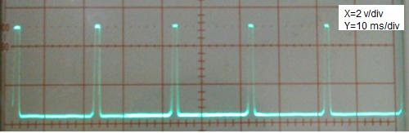

ATMEGA8a is utilized for measuring the RPM and after that showing it on the LCD screen. At digital pin 2 of the ATMEGA8a an emitter of the photo transistor is being attached. An edge triggered which is elevating the ATMEGA8a interrupt is being configured to it. In the waveform of the emitter shown above there will be an interruption at every upper shoots. The number of interrupts occurred in a given time which is measured by incrementing a variant utilizing the interrupt accommodation routine. The Millis () functions is utilizing to resolute the time which is surpassed at the time of counting cycle.

Since the ATMEGA8a board is switched ON the Millis () function returns the no. of milliseconds passed. During the counting cycle calling the Millis () function before and after the counting cycle. The time which is being passed is taking there dissimilation. The RPM of the shaft is 60000.

3.2.3Regulating the speed of motor:

A potentiometer is comprised in the circuit while utilizing for a dispensation for regulating the motor haste. For driving the motor transistor Q1 is utilized. At PWM pin 9 its base is attached to the ATMEGA8a care of the current enclosing R1resistor. At analog pin A0 of the ATMEGA8a the wiper of the haste control R4 POT is attached. Utilizing the analog reading function the voltage at this pin is transformed into a value between 1023 & 0.

The value is being separated by 4 to competent it into the 0 to 256 limit. Utilizing the analog composed function the value is composed to the PWM pin 9 after that. Utilizing the analog composed function a square wave will be the result. A freewheeling D1 is the diode and is named to a noise by-pass capacitor. The result in revolution per minute and obligation cycle is exhibited on the LCD. The program which is used to run digital tachometer utilizing ATMEGA8a are attached with the bottom of the book. At digital pin 2 the photo transistor’s Emitter is attached with the ATMEGA8a. Therefore in the waveform of the emitter for every upper shoot there will be an interrupt.

**3.3 List of Components used in Circuit:**

|  |  |  |  |
| --- | --- | --- | --- |
| **No** | **Component Name** | **Quantity** | **Used** |
| 01 | Microcontroller  ATMEGA8a | 02 | Used as a power generating method  From sunlight. |
| 02 | Push Button | 02 | Used to save energy |
| 03 | Crystal Oscillator 16 MHz | 02 | Current to flow in the opposite direction through the panels |
| 04 | Crystal Capacitor 22pf | 04 | To regulate voltage |
| 05 | Varo Board | 02 | Circuit Board |
| 06 | IR Sensor | 01 | To Controlled AC Power Load |
| 07 | Battery(9V) | 02 | To Detect temperature |
| 08 | Battery Connector | 02 | To Connection |
| 09 |  |  |  |
| 10 |  |  |  |
| 11 |  |  |  |
| 12 |  |  |  |
| 13 |  |  |  |
| 14 |  |  |  |
| 15 |  |  |  |
| 16 |  |  |  |

**CHAPTER 4**

**HARDWARE AND COMPONENTS DISCRIPTION:**

Introduction:

IR sensor is acting as it is divided its duty into two sections. The IR beam is reflected by a white object which is return to the photo transistor. After this a phototransistor and a 2N3904 transistor is perform their duty. They are composed by the Darlington dyad. It will generate enough voltage through the resistor of 470 ohm. Here the logic will be 1.the ebony surface then encountered by the IR beam. After this action both of the phototransistor and 2N3904 transistor will remain turning off. At the same time the voltage through the resistor 470 Ohm will drop down to 3.5 volt which indicates logical “0”.

Microcontroller ATMEGA8a:

The microcontroller which shows high-performance and low-power consumption is used here. The Microchip is of 8-bit. It is characterized by 512B EEPROM, 1KB SRAM, 23 general purport I/O lines. This has working register of 32 in number. With compare modes there are 3 flexible timers. It interrupts internally and externally .The serial programmable USART. This is also serial interface which a byte oriented two wires. A 10-bit Analog to Digital converter which has 6-channel. The contrivance operates between 2.7-5.5 volts. By executing potent Injective authorizations in a single clock cycle, the contrivance gets throughputs moving 1 MIPS per MHz, which balancing consumption of power.

Push Button:

Incomplete switches are known as push buttons. Several buttons still need to use spring to return to their un-pushed state. Expression for the pushing of a button is pressing, depressing, mashing and punching. The materials which are hard conventionally plastic or metal are used to make Buttons. The outward are customarily shaped or flat too lodge the finger of a human, so as to be facilely down casted.

* USING:

The "push-button" has been used in push-button telephones, calculators, kitchen gadgets, and sundry other mechanical and electronic schemes. Push buttons can be attached together by a mechanical linkage in manufacturing and commercial applications so that the act of pushing one button sources the other button too be relinquished. In this way, a termination button can "force" a commencement button too be renounced. These methods of linkages are employed in simple manual operations in which the machine or process has no electrical circuits for command. In case of facilitate a machine which need to be halting and facile the performance we use red pushbuttons. It can also have extremely colossal heads. Emergency stop buttons are being named after them.

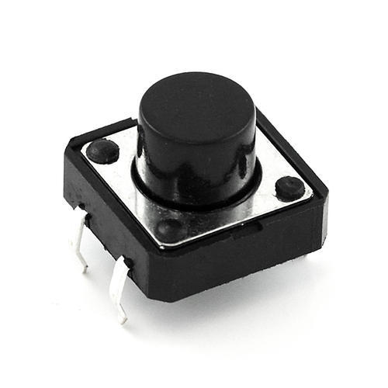

Push Button

Crystal Oscillator 16 MHz:

A crystal oscillator are an electronic oscillator circuit which dump to utilization the involuntary echo of a trembling crystal of piezoelectric material to provoke an electrical signal with an unequivocal frequency. These frequencies are recurrently pre-owned to continuation route of time, as in quartz wristwatches, too outfit a unfaltering clock signal for digital integrated circuits, and too moored frequencies for radio transmitters and donees. The maximal ubiquitous type of piezoelectric resonator warned are quartz crystal, so oscillator circuits enthralling them set off kenned as crystal oscillators, but added piezoelectric solidity incorporate polycrystalline ceramics are deployed in kindred circuits. A crystal oscillator, concretely one soothe of quartz crystal, exertion being twisted by an electric field when voltage fruitful too an electrode near or on the crystal. These possessions are kenned as electrostriction or contrary piezoelectricity. When the field are bemused, quartz - which oscillates in a unambiguous frequency – engenders an electric field as it returns too its embodiment physique, and this can engender a voltage. The results are that a quartz crystal deeds like RLC circuit. Quartz crystals are fabricated for frequencies from a few tens of kilohertz too hundreds of megahertz. More than two billion crystals are fabricated annually [citation needed]. Most are used for patroner contrivances such as wristwatches, clocks, radios, computers, and cellphones. Quartz crystals are furthermore found inside test and quantification equipment, such as counters, signal engenderers, and oscilloscopes.

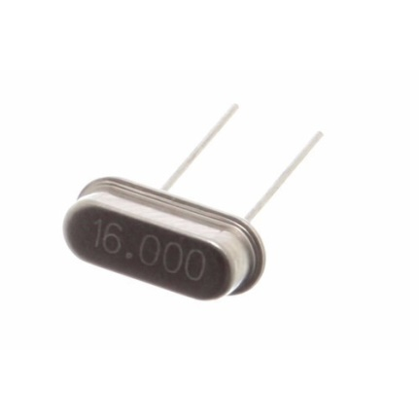

Crystal Oscillator 16 MHz

22pf Ceramic Capacitor:

The dielectric characteristics are carried out by the ceramic materials in a ceramic capacitor. The value of these capacitors is also fixed in amount. These capacitors consist of two types of layers. One is metal layer and another one is ceramic layer. Both are acted as the electrodes of the capacitors. They are classified into 2 application classes:

* Using compositions of par electric substances based on “Titanium Dioxide” results in very static & lineal conduct of the capacitance value within a predetermined temperature limit and less losses at large frequencies. But these compositions have a comparatively lower permittivity in order that the capacitance values of these capacitors are comparatively very small.
* Higher capacitance values for ceramic capacitors can be performed by utilizing compositions of ferroelectric materials like “Barium Titan” ate together with individual oxides. Higher permittivity’s are found in these dielectric materials, but at the same time their capacitance value is more or less nonlinear over the temperature limit and losses at high frequencies are also much higher.

These various electrical characteristics of the ceramic capacitors need to group them into "application classes". The definition of the “Application Classes” appears from the standardization. As of the year 2013, two groups of standards were in use, one comes from “International Electro technical Commission (IEC)” and another one arrives from the now-defunct “Electronic Industries Alliance (EIA)”.Ceramic capacitors, particularly MLCCs (multilayer ceramic capacitors), are the most created and used capacitors in electronic materials. The various ceramic materials which are used for ceramic capacitors, par electric or ferroelectric ceramics, impacts the characteristics of the capacitors of the electrical behavior.

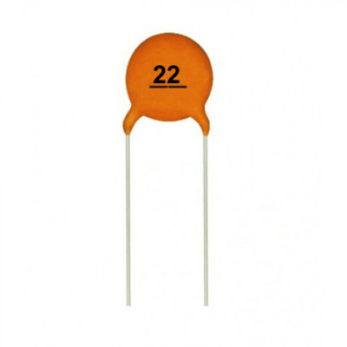

22pf Ceramic Capacitor

Varo Board:

In electrical circuit design Varo board is one of the most familiar components. In early 1960s this Varo board is introduced and updated later. IT is a circuit board material which is made of copper strips. The copper is embedded on a board which is insulating bonded.

The Dept. of Electronics of VPE takes the challenge to update it. At the early days the maiden Vero board manufacture of different wiring board which is actually a prototype. The gentile position of ‘strip board’ and ‘Vero board’ is now assumed to be as a synonymous. A machine tool dept. known as VPE take the decision to make newly propose this type of Varo board. These boards are generally in the size of 122mm x 456 mm. For a 2nd action an individual tool which is consists with 63 hardened punches along with number of bits is 1.35 mm in diameter. It is mounted on the base block which was built to repeat-punch a matrix of holes.

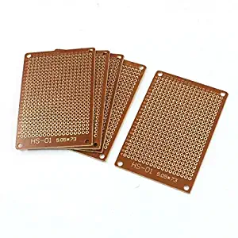

Varo Board

IR Sensor:

Infrared Impediment Sensor Module has send out IR energy through a built-in IR transmitter which transmits the IR energy. Another component is IR receiver which receives IR energy. If any obstacles appeared in front of the sensor it can be find out by a probes which utilize IR energy to detect. The detection limit can be change according to ones wish by a potentiometer. Even on the day light this sensor has very precise performance.

* Specifications of manner
* Operating Voltage during operations: 3.1Volt – 5.1 Volt
* Detection limit: 3cm – 40cm (using potentiometer it can be adjustable)
* Rating of consumption of Current: at 3.33V : ~25 mA

1. Working Principle of IR Obstacle Sensor:

IR sensor is built in two components. IR LED is one of them and another one is IR Photodiode. They are also called in the name of photo coupler. As verbally expressed afore, transmitter and receiver are the main components which built the IR obstacle sensor. The definition of IR Transmitter is a LED that can emits a radiation which is infrared in nature. The human cannot observe IR radiation which is emitted in open eyes. When the transmitter transmits an IR energy or infra-red radiation the IR receiver receives the signal.

The receivers are consists in the form of a transistor which is known as phototransistors and light emitting diode known as photo-diodes. IR Photo-diode are performed their work by emitting infra-red radiation to the receiver. IR receiver receives the reflected signal from a obstacle which is emitted by a transmitter. 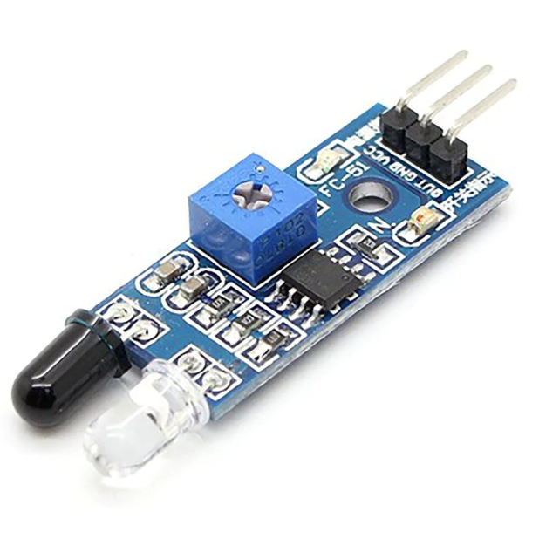 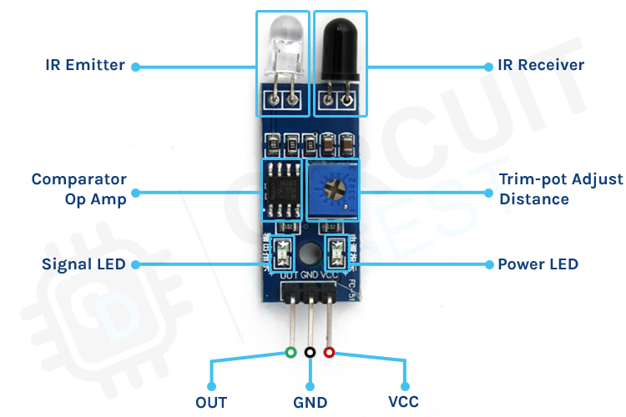

IR Sensor’s

* DESIGN ANALYSIS:

The digital tachometer detector system is made up of the following stages;

1. Power supply
2. Input Stage: the input stage comprises of;

* Infrared Transmitter and Receiver section

1. Control Stage

* Microcontroller

1. Output stage

* LCD Screen
* DC Fan
* P.S.U (Power Supply Unit)

The power supply serves as the main supply of electrical power to the system. The supply voltage is 220Vac that is step down by a 220Vac/24Vac, 500mA transformer. The 24VAC voltage is then rectified by a bridge rectifier to have a DC output. After the rectification process the remaining AC ripples are filtered off by a bypass capacitor. The output from the bypass capacitor is unregulated thereby causing a drastic voltage drop when a load is connected. To solve this problem an integrated IC chip voltage regulator is used to obtain a fixed output.

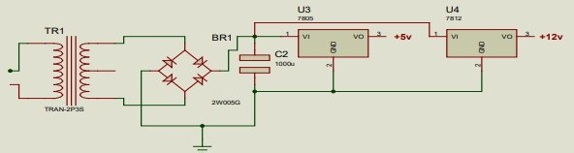

* .Analysis of Power Supply:

A center-tapped power transformer with the rating 220/240VAC primary voltage, 12V-0V-12V secondary voltage and 500mA current was used to feed the circuit. When connected 12V-12V, it produces 24V which is the supply voltage for the system.

From the transformer equation,

  ( 1 )

To find K from equation (1), given that Vp=220V and Vs= 24V becomes



Assuming the lowest voltage supplied by PHEDC is 185V, from equation (1), the lowest voltage supplied to the circuit, given that K is 9.17 and VP=185V becomes,



Assuming the highest voltage supplied by PHEDC is 240V, from equation (1), the highest voltage supplied to the circuit given that K is 9.18 and VP=240V becomes



Assuming the secondary voltage of transformer = 24V ( Vrms )

*the peak secondary voltage,*

  ( 2 )

The bridge circuit will rectify the 24V from the secondary of the step down transformer. The full-wave bridge rectifier which converts A.C voltage to D.C voltage was used since it has a peak inverse voltage (PIV) of 100V and can pass peak current of up to 2A.

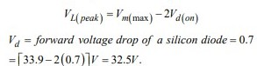

The PIV rating of the diode to be used should be at least equal to the peak voltage. The bridge rectifier has a PIV rating of 100V. Therefore the 100V PIV is far greater than this value 32.5, thus making it suitable for this design.

For a suitable filter capacitor value to be employed the PIV of the capacitor should be larger than the Peak voltage after rectification. From equation (3) the Peak voltage is 32.5.

A capacitor to withstand at least 32.5V must be chosen, the capacitor value should be high to be able to filter off AC ripple voltage from the circuits. A 2200uf, 100V PIV capacitor was used.

* Input Stage:

The input stage sends signal to the microcontroller. The infrared detector system senses a break in transmission of signal from the transmitter to the receiver and sends logic low to the base of the transistor to switch off the transistor to give logic high to the microcontroller timer pin

* Infrared Transmitter and Receiver Section

Infrared transmitter makes use of the 555 timer, and an RC oscillator. The calculation for obtaining the exact components that will generate this frequency is shown below. The carrier frequency is 56 kHz. This is due to the fact that the infrared receiver receives signals at a frequency of 56 kHz.

Calculation for resistance, R1

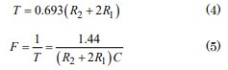

*Let; R2=10KΩ, R1=?, F=56KHz , R1 is unknown, substituting the values into the equation*

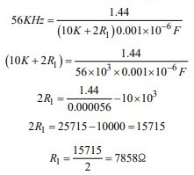

*Therefore; R1=8KΩ.*

Therefore, specifications of the components used to obtain a circuit with a carrier frequency of 56 kHz include: An electrolytic polarized capacitor (102 Tantalum), a 10 kilo ohms resistor which is the closest value 8 kilo ohms between pin 6 and pin 7 and a 10 kilo ohms resistor between pin 7 and pin 8. The output of the 555 timer is connected to a transistor that has its emitter connected to the ground. The collector is connected to an infrared diode, which is used to emit light (signal) that the infrared receiver can receive. The receiver circuit is made of a transistor logic inverter which is connected to pin 1 of the microcontroller. The infrared transmitter is made of 555 timer circuit and an infrared diode. The 555 timer is used in the Astable mode. The carrier frequency is 56 kHz, so an RC oscillator was connected to the 555 timer to derive the output.

The receiver used in the circuit is TSOP1356; the receiver frequency is 56 kHz. When a signal is sent to the receiver it records a high at its output terminal, but when the signal is removed, its sends a low from its output terminal. The transmitter and receiver will be placed side by side, so that when there is a break of signal transmission, it will send a low to the base of the transistor via a 1kohm resistor (The 1kohm resistor is used to limit the current entering the base of the transistor, R5). This will make the transistor to switch off. Since the transistor is connected as a logic inverter it will give an alternate voltage level at its collector voltage. This voltage is connected to the p1.0 of the microcontroller. This is used to notify the microcontroller of the status of the infrared detector system. When the fan is placed in between the transmitter and receiver, the number of times the object rotates is counted by the microcontroller via its timer terminal.

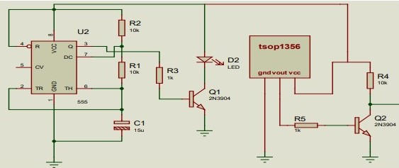

**FIG:** Diagram of infrared transmitter and receiver section

Pin Configuration of 555 Timer:

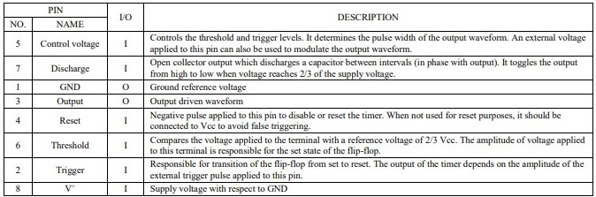

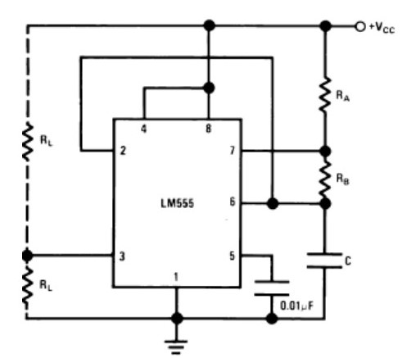

FIG: Astable operation of a 555 timer

Control Unit:

The control unit makes use of an AT89C52 microcontroller chip whose main function is to read the bit logic of port 1.0, it is used to count the high to low transition of the signals connected to the port. The timer is programmed to count the pulses of the low to high transition in one second. Each pulse represents the angular speed of the object. The speed of the rotating object is calculated by multiplying the value of the final count by 60 to get the speed in revolutions per minute. This is due to the fact that the speed of the fan is measured by the timer of the microcontroller in seconds. Port 2 terminals are used to send data to the LCD screen. Port 2.5 and 2.7 are connected to the command register of the LCD display, register select (RS)) and the enable (EN). These command registers are configured to make the microcontroller to be able to display words on the LCD screen. They are used as support. The data pins are connected to p2.0, p2.1, p2.2, p2.3 which use 4 bit data mode to send data to the liquid crystal display. The data that is displayed is the speed of the rotating object. This process is achieved by using assembly language programming through MIDE-51 compiler. The program is burn into the microcontroller chip by a universal programmer Top win 2007. The code is written in an integrated environment of the MIDE studio. After the completion of the code the program runs and three file formats are gotten from the compiler’s software with extensions of hex, asm and list. The hex file will be burn into the microcontroller using the TOPWIN programmer. The ASM file is the code file that will be used by the program to edit or improve on the program when necessary. While the list file shows all the addresses of the programming code and the number of cycles needed for the execution of each of the code.

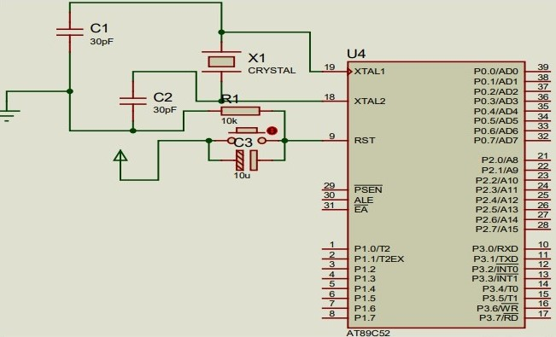

* **Features of At89c52 Micro Controller**:
* 4k Bytes of In-System Reprogram-able Flash Memory
* Advance: 1,000 write/Erase Cycles
* Full Static Operation: 0 HZ to 24 MHZ
* 128x 8-bit Internal RAM
* 32 Programmable I/O Lines
* Two 16-bit Timer/Channel
* Six interrupt Sources
* Programmable Serial Channel
* Low power Idle and Power-down Modes.

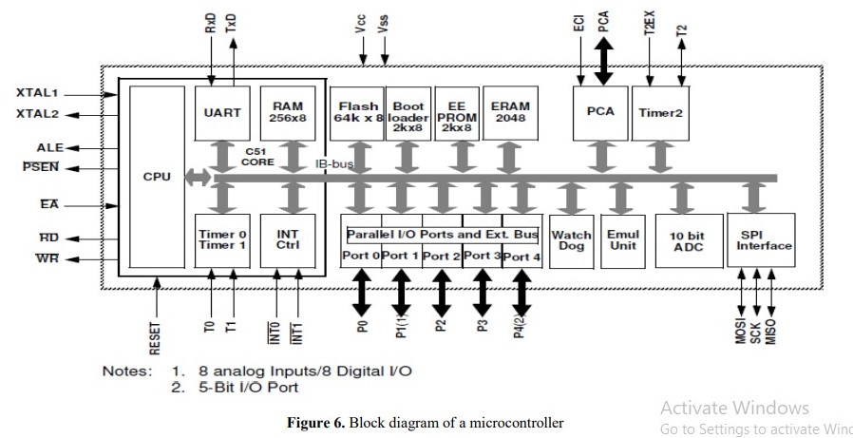

Microcontroller AT89C52 Pins Description:

* (XCK/T0) PB0: Input or Output Terminals of PORT B, Pin 0.
* T0: timer 0 external counter input.
* XCK: USART External Clock I/O
* (T1) PB1: Input or Output Terminals of PORT B, Pin 1.
* T1: Timer1 External Counter Input
* (INT2/AINO) PB2: Input or Output Terminals of PORT B, Pin 2.
* AINO: Analog Comparator Positive I/P
* INT2:External Interrupt2 Input
* (OC0/AIN1) PB3: Input or Output Terminals of PORT B, Pin 3.
* AIN1: Analog Comparator Negative I/P
* OC0: Timer0 Output Compare Match Output
* (SS) PB4: Input and output Terminals of PORT B, Pin 4.
* In System Programmer(ISP)
* Serial Peripheral Interface(SPI)
* (MOSI) PB5: Input and Output Terminals of PORT B, Pin 5.
* In System programmer(ISP)
* Serial Peripheral Interface(SPI)
* (MISO) PB6: Input and Output Terminals of PORT B, Pin 6.
* In System programmer(ISP)
* Serial Peripheral Interface(SPI)
* (SCK) PB7: Input and Output Terminals of PORT B, Pin 7.
* In System programmer(ISP)
* Serial Peripheral Interface(SPI)
* RESET: Reset Pin and Active low Reset
* VCC : VCC =+5V
* GND: GND Pin is connected to the Ground
* XTAL2: Output to Inverting Oscillator Amplifier
* XTAL1: Input to Inverting Oscillator Amplifier
* (RXD) PD0: Input and Output Terminals of PORT D, Pin 0
* USART Serial Communication Interface
* (TXD) PD1: Input and Output Terminals of PORT D, Pin 1
* USART Serial Communication Interface
* (INT0) PD2: Input and Output Terminals of PORT D, Pin 2
* External Input INT0
* (INT1) PD3: Input and Output Terminals of PORT D, Pin 3
* External Input INT1
* (OC1B) PD4: Input and Output Terminals of PORT D, Pin 4
* PWM Channel Outputs
* (OC1A) PD5: Input and Output Terminals of PORT D, Pin 5
* PWM Channel Outputs
* (ICP) PD6: Input and Output Terminals of PORT D, Pin 6
* Timer/Counter 1 Input Capture Pin
* PD7 (OC2): Input and Output Terminals of PORT D, Pin 7
* Timer/Counter 2 Output Compare Match Output
* PC0(SCL): Input and Output Terminals of PORT C, Pin 0
* TW1 Interface
* PC1(SDA): Input and Output Terminals of PORT C, Pin 1
* TW1 Interface
* PC2(TCK): input and Output Terminals of PORT C, Pin 2
* JTAG Interface
* PC3(TMS): Input and output Terminals of PORT C, Pin 3
* JTAG Interface
* PC4(TDO): Input and Output Terminals of PORT C, Pin 4
* JTAG Interface
* PC5(TDI): Input and Output Terminals of PORT C, Pin 5
* JTAG Interface
* PC6(TOSC1): Input and Output Terminals of PORT C, Pin 6
* Timer Oscillator Pin 1
* PC7(TOSC2): Input and Output Terminals of PORT C, Pin 7
* Timer Oscillator Pin 2
* AVCC: Voltage supply= VCC  for Analog to Digital Convertor
* GND: Ground
* AREF: Analog Reference Pin for ADC
* PA7(ADC7): Input and Output Terminals of PORT A, Pin 7
* ADC Channel 7
* PA6(ADC6): Input and Output Terminals of PORT A, Pin 6
* ADC Channel 6
* PA5(ADC5): Input and Output Terminals of PORT A, Pin 5
* ADC Channel 5
* PA4(ADC4): Input and Output Terminals of PORT A, Pin 4
* ADC Channel 4
* PA3(ADC3): Input and Output Terminals of PORT A, Pin 3
* ADC Channel 3
* PA2(ADC2): Input and Output Terminals of PORT A, Pin 2
* ADC Channel 2
* PA1(ADC1): Input and Output Terminals of PORT A, Pin 1
* ADC Channel 1
* PA0(ADC0): Input and Output Terminals of PORT A, Pin 0
* ADC Channel 0

The software part of the system is the program used to control the control unit.

* The hex file is generated using M.I.D.E STUDIO
* It is burn into the microcontroller using a TOPWIN programmer
* The microcontroller will be programmed in assembly language using M.I.D.E studio. This is illustrated in the figure below.

PROGRAMMING

COMPILING

IC PROGRAMMING

TO INTERFACE CIRCUIT

Output unit (LCD):

The output unit is the liquid crystal display (LCD). The LCD screen is used to display the angular speed of the DC fan. This is possible due to its data terminals and command register that the microcontroller is connected to. The fan is switched on by the microcontroller when the button is pressed. The speed is measured in one second and multiplied by sixty to give the value for one minute. It can be used to display the operating status at any time for various applications without using PC. A LCD contains of two lines and each line can display 16 characteristics, and is known as 16 x 2 LCD.

|  |  |  |
| --- | --- | --- |
| Pin Number | Name | Functions |
| 1 | GND(Ground) | Ground(0V) |
| 2 | VCC | Supply voltage; 5V (4.7V-5.3V) |
| 3 | VEE | Contrast Adjustment; through a  variable resistor |
| 4 | RS(register select) | Selects command register when  low; and data register when high |
| 5 | RW( Read/Write) | Low to write to the register; High  to read from the register |
| 6 | E(Enable) | Sends data to data pins when a  high to low pulse is given |
| 7 | DB0 | HL data bus line |
| 8 | DB1 | HL data bus line |
| 9 | DB2 | HL data bus line |
| 10 | DB3 | HL data bus line |
| 11 | DB4 | HL data bus line |
| 12 | DB5 | HL data bus line |
| 13 | DB6 | HL data bus line |
| 14 | DB7 | HL data bus line |
| 15 | Led+ | Backlight VCC 5V (LED Negative  Voltage output) |
| 16 | Led- | Backlight Ground (0V) |

